Supporting Documentation – Best New Innovative Product – European Casino Awards

Link to publicly available video on LinkedIn & DigiWheel Social media Channels of large crowd gathered around this innovative device showcasing the extremely busy casino floor with the wheel being used to marry casino marketing and gaming. This video can be found on LinkedIn here.

Images of DigiWheel Classic on Site & In Use at The Hippodrome Casino, London and Les Ambassadeurs Casino, London:

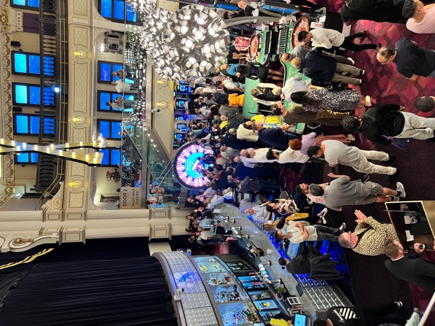
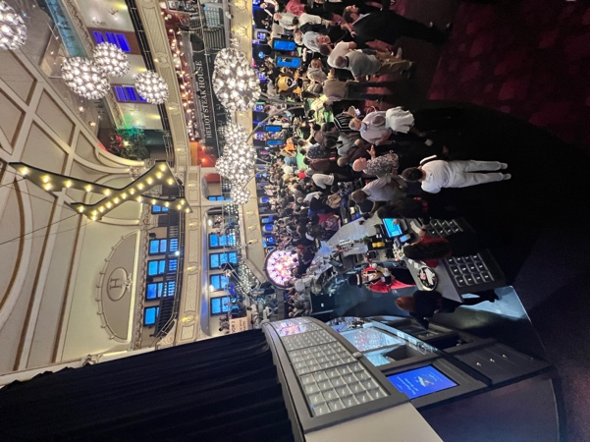
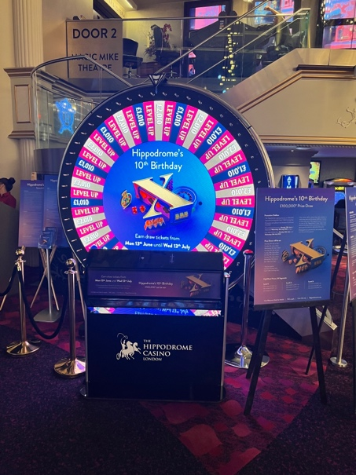
Hippodrome Casino:

Les Ambassadeurs:
